Lab Manual

Data Communication Networks

BCA324

III

NAME = SUJAL KHUNT

ENROLL = 24FOTCA13902

TUTORIAL 8

Q-1)Find the IP address of 5 web sites that you know using NSLOOKUP command. also explore NSLOOKUP in detail.

Ans-nslookup [www.google.com](http://www.google.com/)

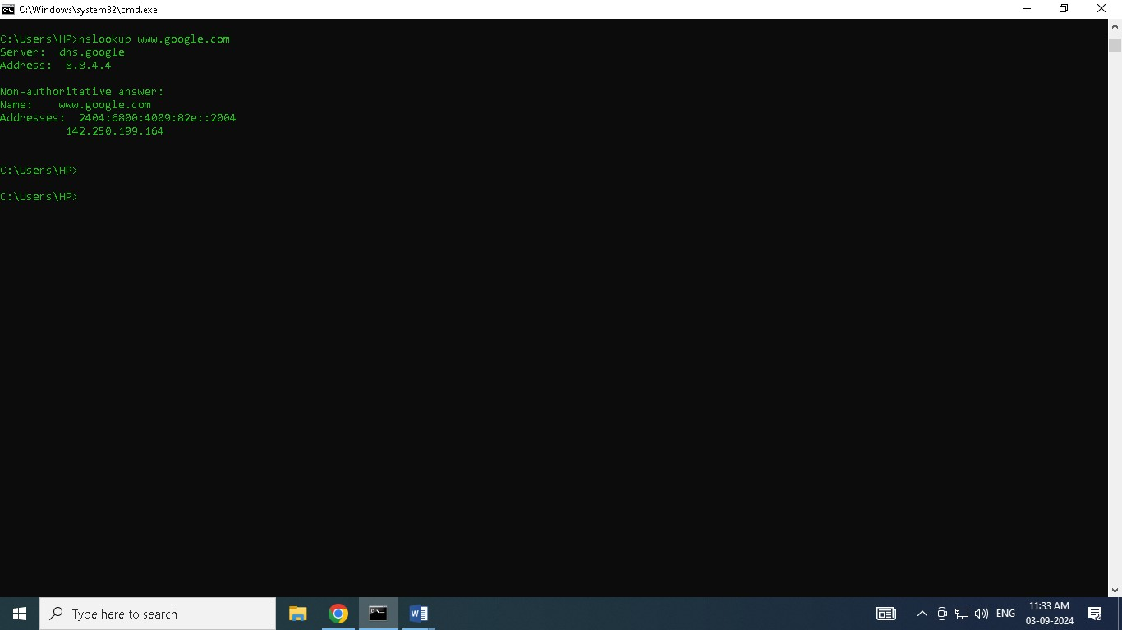

5 Example of nslookup

EX-1

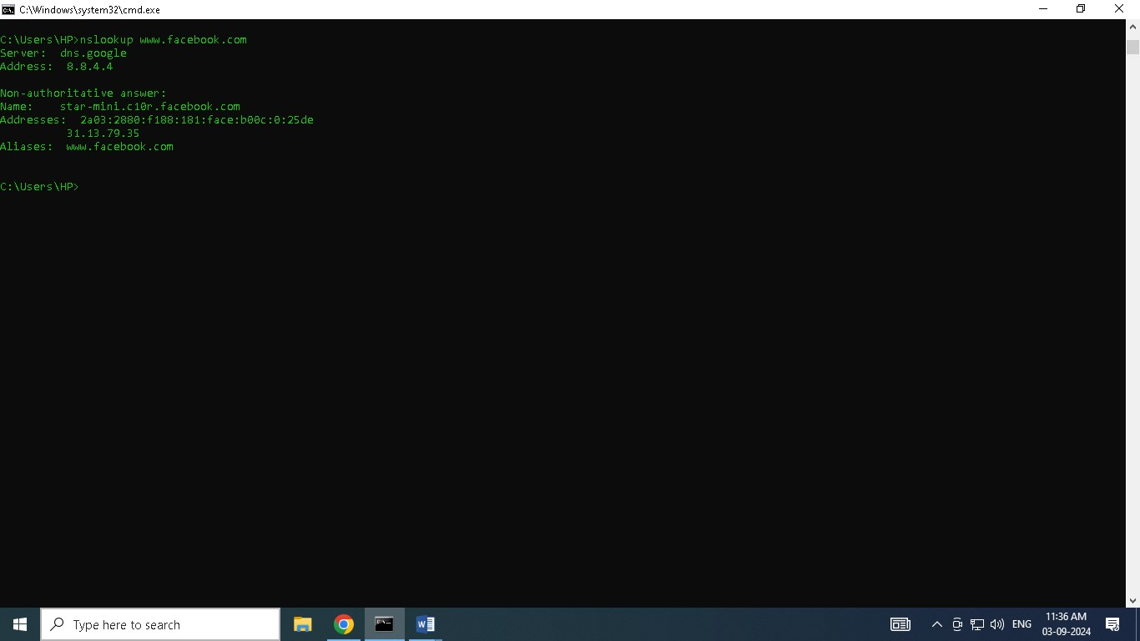

Ex-2

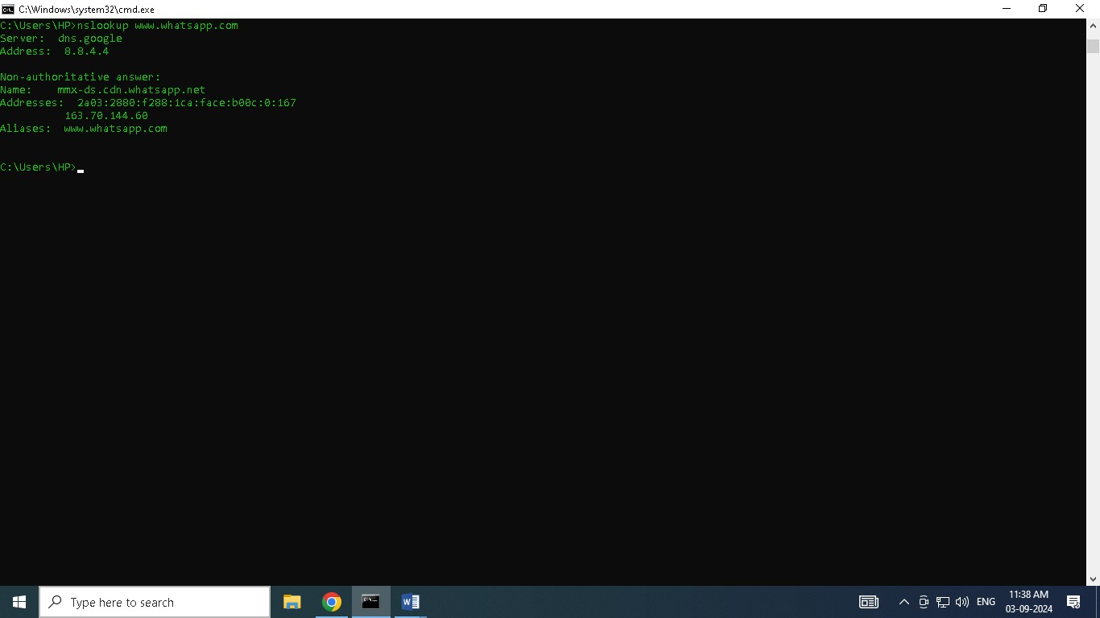

Ex-3

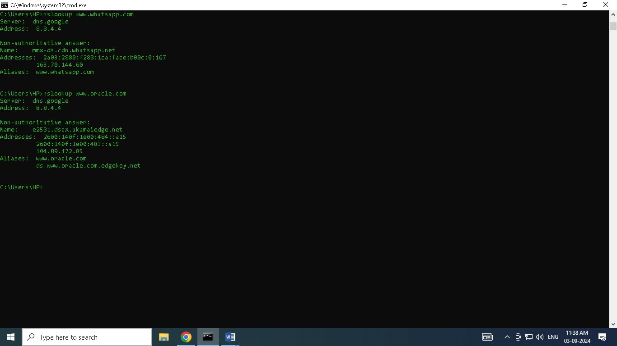

EX-4

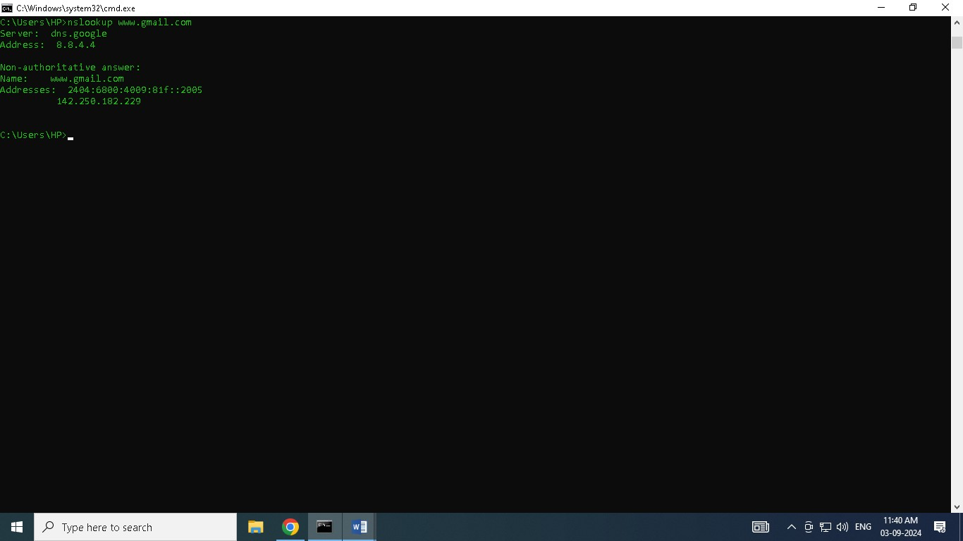

Ex-5)

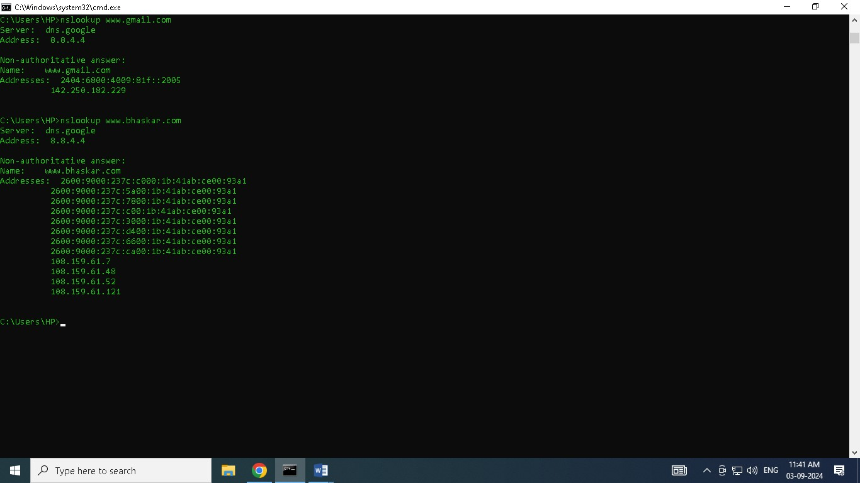

-----------------------------------------------details about nslookup--------------------------------------------- nslookup can be used in two modes: *interactive* and *non-interactive*.

1. Non-Interactive Mode:

- The examples above show the non-interactive mode, where you enter a single query and get a quick response.

2. Interactive Mode:

* You enter the interactive mode by simply typing nslookup and pressing Enter.
* Once in interactive mode, you can type multiple queries one after the other.
* Type exit to leave interactive mode.

Common Options in nslookup:

* *Change DNS Server:*
* By default, nslookup uses your system’s DNS server. To query using a different DNS server:

bash

nslookup [domain] [DNS server]

* Example: nslookup www.google.com 8.8.8.8 (uses Google's public DNS).

* View All DNS Records:
* To see all DNS records for a domain:

bash

nslookup -query=any [domain]

* Find Mail Server Records (MX records):
* To find the mail servers for a domain:

bash

nslookup -query=mx [domain]

* View Name Server Records (NS records):
* To find the name servers for a domain:

bash

nslookup -query=ns [domain]

Use Cases for nslookup:

* Troubleshoot DNS issues: If you can’t access a website, use nslookup to see if it’s a DNS issue.
* Verify DNS records: Check that DNS records are correctly set up for a domain.
* Identify IP addresses: Quickly find the IP address of a domain name.

nslookup is a versatile tool for anyone dealing with network administration or troubleshooting DNS-related issues.